Learning rate comparison experiment, October 9

15 minute training time on 27440 train images and 6853 test images.

0.001 Learning rate Classification Report:

precision recall f1-score support

bright dune 0.94 0.97 0.95 979

crater 0.80 0.79 0.80 979

dark dune 0.96 0.87 0.91 979

impact ejecta 0.97 0.97 0.97 979

slope streak 0.82 0.91 0.86 979

spider 0.95 0.97 0.96 979

swiss cheese 0.89 0.83 0.86 979

accuracy 0.90 6853

macro avg 0.90 0.90 0.90 6853

weighted avg 0.90 0.90 0.90 6853

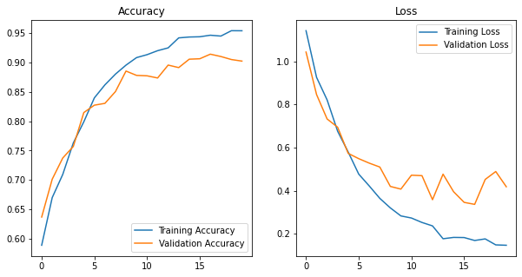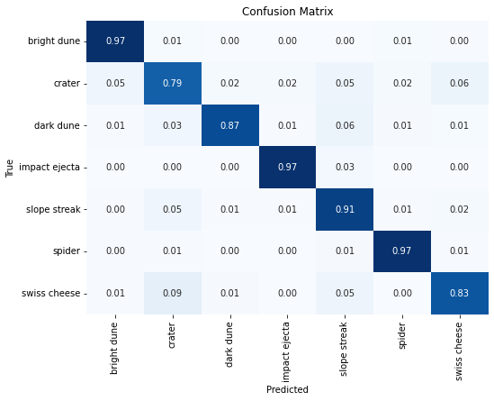Peak accuracy at 16 epochs

0.0005 learning rate Classification Report:

precision recall f1-score support

bright dune 0.94 0.97 0.95 979

crater 0.90 0.81 0.85 979

dark dune 0.96 0.93 0.95 979

impact ejecta 0.98 0.99 0.98 979

slope streak 0.88 0.89 0.89 979

spider 0.96 0.96 0.96 979

swiss cheese 0.87 0.94 0.91 979

accuracy 0.93 6853

macro avg 0.93 0.93 0.93 6853

weighted avg 0.93 0.93 0.93 6853

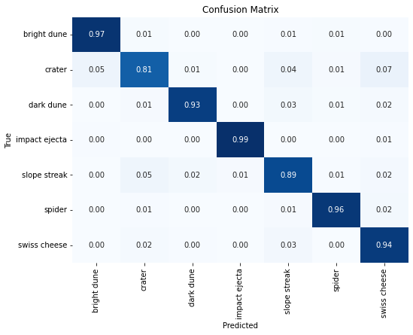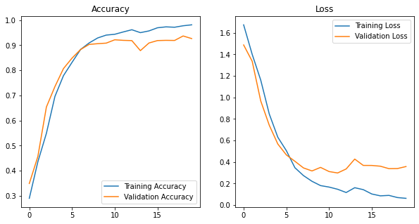Peak accuracy at 19 epochs

0.0001 learning rate Classification Report:

precision recall f1-score support

bright dune 0.95 0.99 0.97 979

crater 0.90 0.89 0.89 979

dark dune 0.96 0.95 0.95 979

impact ejecta 0.98 1.00 0.99 979

slope streak 0.95 0.91 0.93 979

spider 0.99 0.98 0.99 979

swiss cheese 0.95 0.97 0.96 979

accuracy 0.95 6853

macro avg 0.95 0.95 0.95 6853

weighted avg 0.95 0.95 0.95 6853

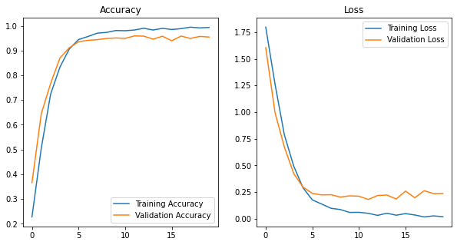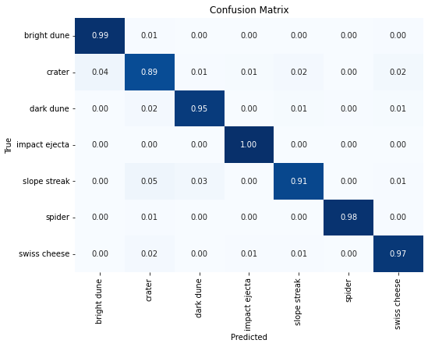\

Peak accuracy at 16 epochs

0.00001 learning rate Classification Report:

precision recall f1-score support

bright dune 0.89 0.93 0.91 979

crater 0.79 0.64 0.71 979

dark dune 0.83 0.85 0.84 979

impact ejecta 0.82 0.93 0.87 979

slope streak 0.73 0.82 0.77 979

spider 0.92 0.93 0.92 979

swiss cheese 0.90 0.78 0.84 979

accuracy 0.84 6853

macro avg 0.84 0.84 0.84 6853

weighted avg 0.84 0.84 0.84 6853

